2018 SSYC 2nd ANNUAL FISHING TOURNAMENT
Saturday September 8th – Sunday September 9th
Captains Meeting Friday Night @ 7PM - SSYC

*CASH PRIZES RAFFLE TROPHY-PARTY-FOOD

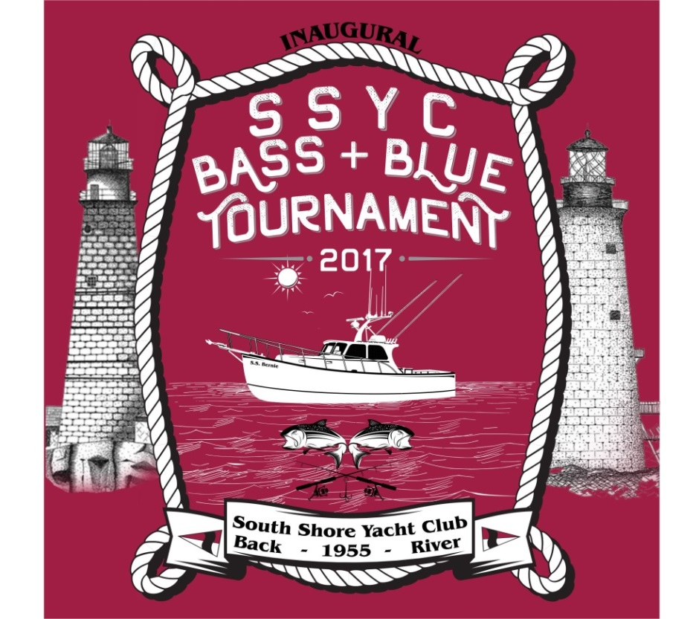
Raffle Prizes:

TBD

LIVE ENTERTAINMENT:

Martin Joyce
Sponsored by:

Johnny Konos Bar & Grill
Deep Eddy Vodka
TBD

CASH PRIZES:

Bass 1st Place: *$250
Blue 1st Place: *$250

Boat Tournament
$100 per Boat for 3 Anglers Maximum - $50 each additional Angler
-Calcutta-

Registration after 8/30 will be considered based on availability.

*Amount Subject to Change – The final amount of Cash Prizes is dependent on participation and will be adjusted accordingly. Final amount will be announced at the Captains Meeting. This is a Non-Profit Event, with all profits towards expenses and prizes.

Register by emailing Mike Romans at SSYCROMANS@comcast.net providing names of each angler on your team together with their shirt size, size of boat & boat name.
Captains are responsible for registering all anglers on their team providing name and shirt size.

There will be a captain’s meeting 9/7 @ 7PM at SSYC. Lines wet 9/8 @ 6AM. There will be food & entertainment at the Tiki Hut during the final weigh-in and prize announcements.

A complete listing of the Rules & Regulations for this Bass & Blue Tournament will be provided upon Registration and at the Captains Meeting.

